**EXPRIMENT NO-13**

**CSA1142-OBJECT ORIENTED ANALYSIS AND DESIGN**

**BPO SYSTEM MANAGEMENT**

**USE CASE**

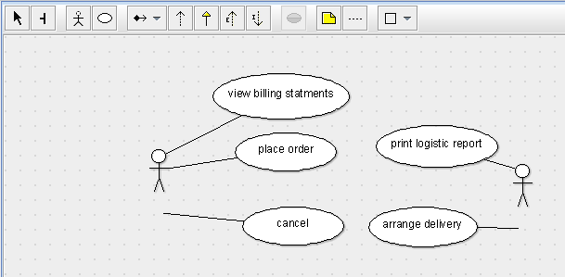

STATE DIAGRAM

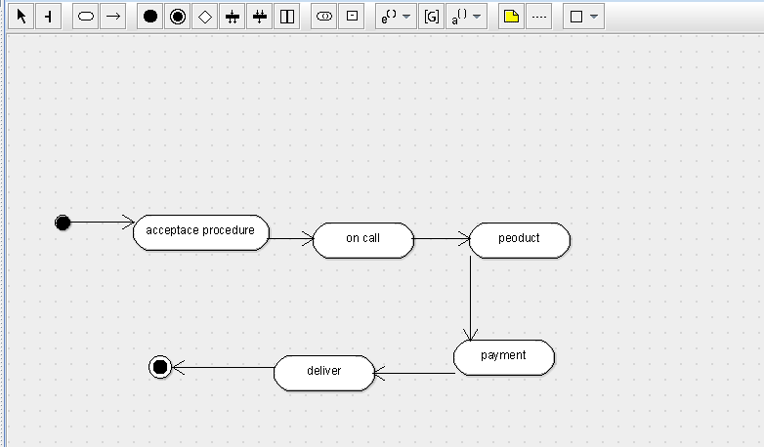

SEQUENCE DIAGRAM

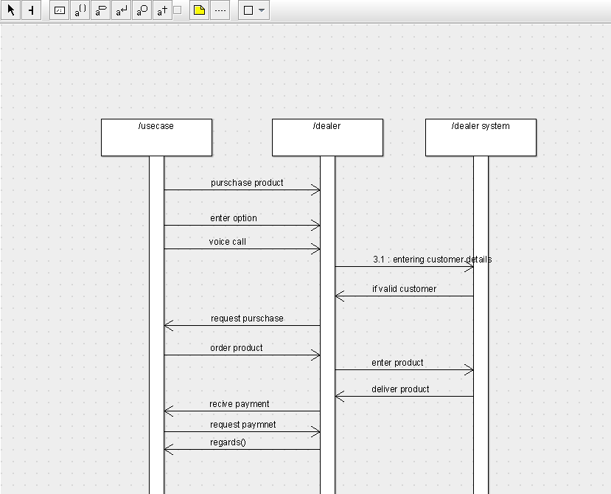

DEPLOYMENT DIAGRAM

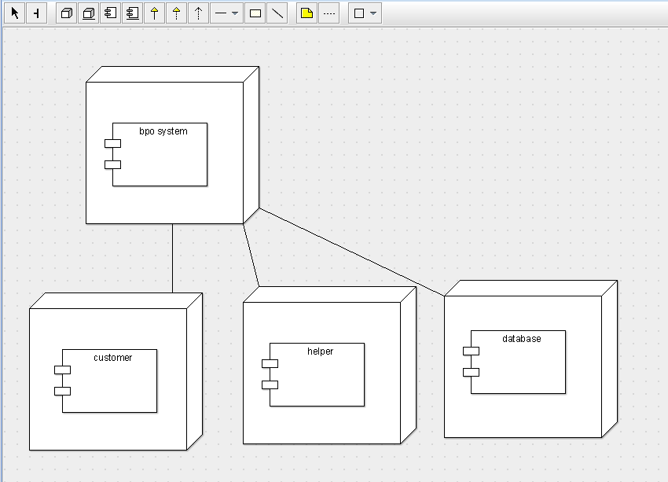

COMPONENT DIAGRAM

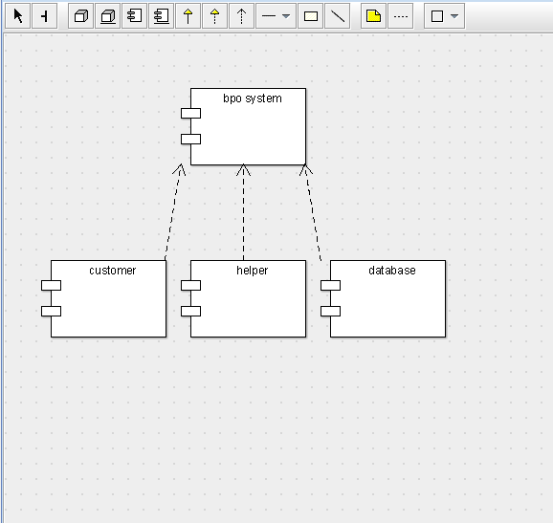

COLLABORATION DIAGRAM

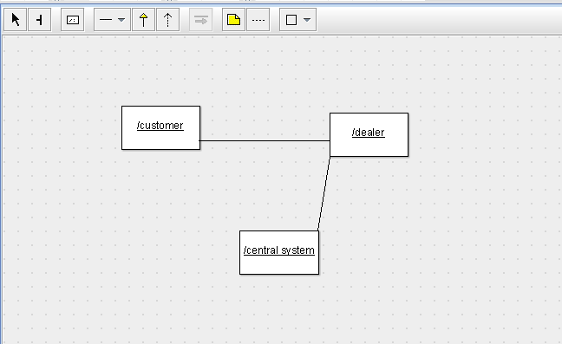

CLASS DIAGRAM

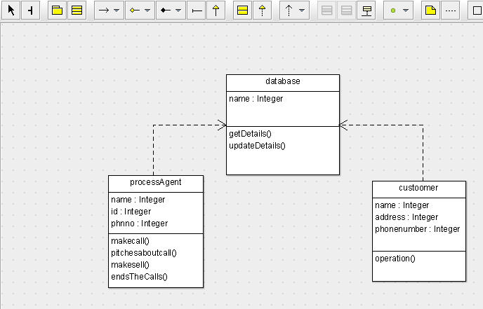

ACTIVITY DIAGRAM

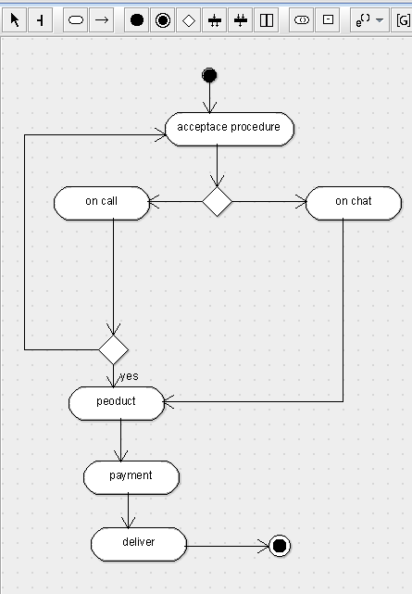

SKELETON CODE;

public class database {

  public Integer name;

  public void getDetails() {

  }

  public void updateDetails() {

  }

}

public class custoomer {

  public Integer name;

  public Integer address;

  public Integer phonenumber;

  public void operation() {

  }

}

public class processAgent {

  public Integer name;

  public Integer id;

  public Integer phnno;

  public void makecall() {

  }

  public void pitchesaboutcall() {

  }

  public void makesell() {

  }

  public void endsTheCalls() {

  }

}